ADVENTURE WORKS · TECHNICAL SUPPORT

Gears Won't Shift Smoothly (Indexing)
Drivetrain Document TS-004 Rev. A
Applies to | All geared Adventure Works models
Difficulty | Intermediate
Time required | 20 – 40 minutes
Tools needed | Hex keys, Cable cutters (if replacing cable), Repair stand (recommended)

Symptoms
- Slow, hesitant, or noisy shifts that don't land cleanly on a cog.
- The chain rattles or 'chatters' as if caught between two gears.
- It shifts fine in one direction but not the other.
- It will not reach the largest or smallest cog.
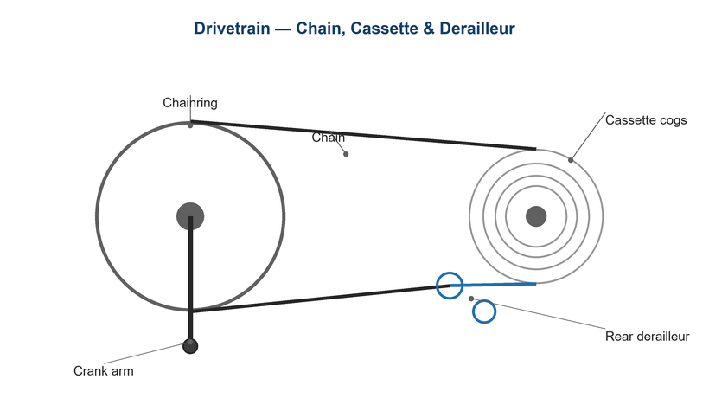
Figure 1. Indexing aligns the derailleur precisely under each cog.

Likely Causes
- Incorrect cable tension after stretch or a previous adjustment.
- High/low limit screws set wrong, blocking access to end cogs.
- Dirty, kinked, or corroded shift housing adding friction.
- Bent derailleur hanger.
- B-tension set so the guide pulley is too far from the cogs.
Safety first
- Keep fingers away from the spinning chain and chainring while pedaling by hand.
- Support the bike securely so the rear wheel can spin freely.
- Wear eye protection if cutting cable or housing.

Customer Fix — Step by Step
Suitable for home repair with basic tools. Work through the steps in order.
- Shift to the smallest rear cog and the smallest front chainring to release cable tension.
- If the chain is slow to move to a larger cog, turn the rear barrel adjuster counter-clockwise a quarter turn to add tension; turn clockwise if it overshoots.
- Pedal by hand and shift one cog at a time, adjusting a quarter turn until each shift is immediate and quiet.
- If the chain won't reach the largest or smallest cog, the limit screws likely need adjustment (technician step).
- Apply a drop of light lube where the cables enter the housing and work the shifter several times.
- Re-test through the full range; quiet, instant shifts indicate correct indexing.

Technician Reference
Additional checks and adjustments for service technicians and advanced users.
- Set the high (H) limit so the guide pulley aligns under the smallest cog; set the low (L) limit under the largest cog without overshooting into the spokes.
- Reset cable tension from zero: with the chain on the smallest cog, just snug the cable, then index from there.
- Inspect and, if gritty or kinked, replace the shift housing and inner wire; use sealed housing ends.
- Check and correct hanger alignment with a gauge.
- Adjust B-tension for a 5–6 mm guide-pulley-to-cog gap.
- Confirm front derailleur height (1–3 mm above the big ring) and angle parallel to the chainrings.

Torque & Specifications
Fastener / setting | Specification
Shifter cable pinch bolt | 5 – 7 N·m
Front derailleur clamp | 5 – 7 N·m
FD height above big ring | 1 – 3 mm
Guide-pulley-to-cog gap | 5 – 6 mm
Barrel adjuster step | ¼ turn at a time

Figure 2. Limit screws stop the derailleur from over-traveling into the frame or spokes.
Pro tips
- Make all adjustments a quarter turn at a time and test between each.
- Replace shift cables yearly if you ride in wet or dusty conditions.

When to Visit a Service Center
- Shifting is still poor after a fresh cable and correct indexing.
- The hanger is bent and no alignment gauge is available.
- An electronic (Di2/AXS) system reports an error or won't pair.
- The shifter ratchet feels broken or won't hold tension.
This guide is provided for reference. Torque values are typical starting points — always follow the specific component manufacturer's instructions. © Adventure Works.

